Review of BASK/ACPA Parallel Meeting 2015

Venue: Leicester City Football Club, King Power Stadium
Date 20th – 22nd March 2018

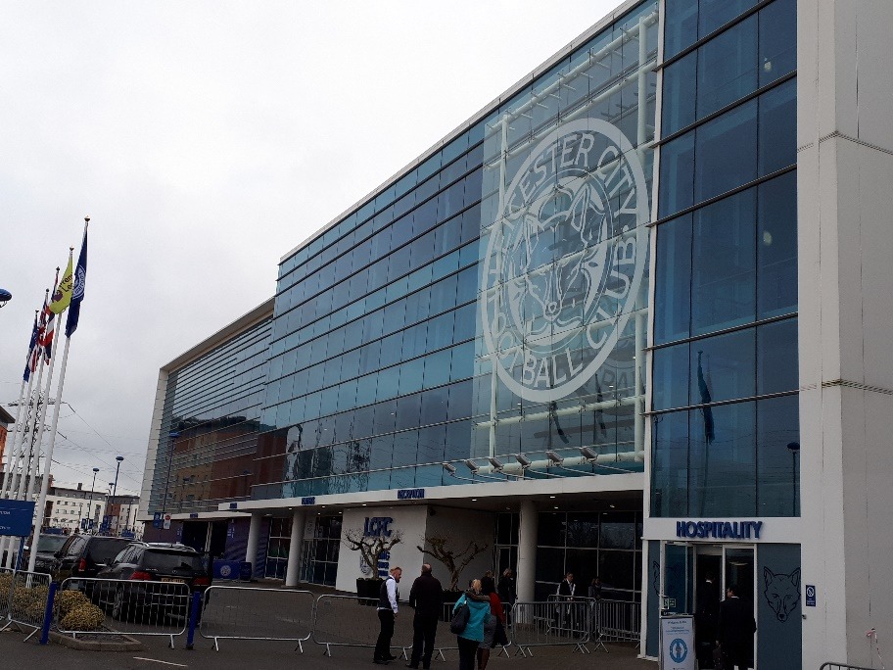

Again, this year the ACPA meeting was a quality event at a quality venue with quality speakers. The whole conference was not only enjoyable but thought provoking, informative and completely relevant to my practice own as a Surgical Care Practitioner. The annual parallel meetings with BASK and BHS is one of those few occasions where one can acquire invaluable knowledge that will help shape the arthroplasty practitioner’s role and practice. For those of us who were fortunate enough to attend, given the immense financial pressure we all face these days, these meetings offer up not only a wonderful opportunity to benchmark what we do against what is practiced around the country, but also offers a hugely important opportunity to meet colleagues (old and new) and to create bridges between us. ACPA is a family, our members are an extremely important asset to Trusts up and down the country and they make an enormous difference to patient-centred care in the orthopaedic world.
This year the event was organised by Claire Stevens and her colleagues at Derby. The success of the meeting was a tribute to their hard work. ACPA is certainly grateful for time, effort and organisation involved. If anyone has not attended this event, at any time in the past, I would urge you to do so. You would certainly benefit from attending.
This year’s first speaker was Colin Esler (BASK President). Colin’s task in introducing the meeting was both full of whit and eloquence. It was, to be fair, made somewhat easier by the fact that he was able to draw from two recent episodes in Leicester’s history. Firstly, the conference itself was held in the King Power Stadium where Leicester City FC fought an epic battle to become Premier League Football Champions in 2016. Keeping on the sporting theme, ‘Leicester Tigers’ Rugby Union side also gained comments of praise based on their sporting achievements over recent years. Secondly, and for those of you who are less interested in sport, Mr Esler talked of the finding of the skeletal remains of King Richard III in a local car park in Leicester. It is certainly right that Leicester has now been put even more firmly ‘on the map’ because of Richard III and not because of its Car Parks!
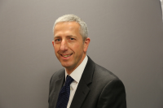
Following Mr Esler, The ACPA parallel meeting began. The meeting was open by Clare-Louise Sandell, who after two years as ACPA President steps down. Clare-Louise thanked the organising committee and welcomed all who attended.

The meeting opened with Mr Tim Wilton (Consultant Orthopaedic Surgeon, Royal Derby Hospital) who was himself a former BASK and BOA President. Mr Wilton’s talk ‘The Role of the Arthroplasty Practitioner in Validating Data’ asked the question, what could be the role of the Arthroplasty Practitioner following GIRFT (getting it right first time) implementation?

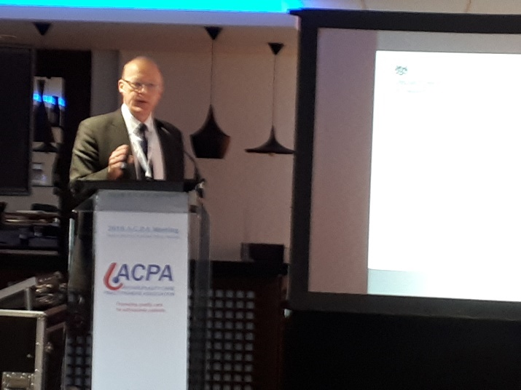

Mr Wilton recapped on the background of GIRFT, launched in 2014, and it’s implementation advice. GIRFT appears to aim to want to prevent surgeons doing surgery in a certain manner and stopping surgeons who do a small number of cases in a year on the premise that a single failed surgical result can make a big difference to surgeon statistics. However, Mr Wilton disagrees with that logic. He alluded to the fact that unit meetings around the country have been patchy, some hospitals have embraced the GIRFT concept whilst others have changed practice or elements of practice. Mr Wilton suggested that perhaps Arthroplasty Care Practitioners can bring a balance to what occurs and take an active role in verifying data as they are not biased in this process.
Mr Wilton explained that GIRFT identifies areas of divergence from best practice. Key performance indicators are used for this purpose. From this e.g. it is suggested that cemented prostheses have lower failure rates than uncemented prostheses. However, using one indicator is not always appropriate. Mr Wilton discussed ODEP ratings and the good and less good points surrounding that classification. GIRFT also underlines how performing knee arthroscopy on knees approaching a need for knee replacement is also not good practice.
Data reporting on e.g. infection incidence can be ‘soft’ in some hospitals and the numerous data systems (NJR, PROMS, SSI, HES, unique hospital database) that are used complicates this issue. In interpreting data, the aim is to be within two standard deviations of an acceptable level of practice. Transgression beyond that level leads surgeons and units to become outliers. So, Mr Wilton impressed on the audience that it is important to question data findings and how data is collected. In Derby they looked at their hip data which suggested 90% of hips were cemented and 100% were using ODEP 10A rated components. The truth was that 100% of femoral components were ODEP 10A but not all acetabular components (uncemented) were specifically 10A rated. Therefore, Data is wrong. Care should also be taken when looking at HES (hospital Episode Statistics) as it depends highly on correct coding!
ODEP ratings have changed over the past two years. A* ratings are now in place. NICE suggests <10% failure rates over 10 years (i.e. 90% survivorship at 10 Years). However, UNI KR and PFJ implants could not receive a rating. A 13A* category (based on more than three centres producing data for implants used) is being introduced. Essentially revision rates therefore depend on the type of implant used. Above 2% is the benchmark in revision rates (on average 1% hips fail). Some implants such as those patient specific implants (e.g, DDH surgery) do not acquire large enough numbers for reliable analysis and as such these implants can never acquire a 10A* rating.
For arthroplasty care practitioners to understand data analysis they require to learn or possess understanding of statistical terms (funnel plots/standard deviation etc). Certainly, failure rates are affected considerably by hospitals undertaking low numbers. In these hospitals, if small numbers of procedures go on to be revised the hospital falls outside the average hospital comparison curve very quickly. Some hospitals will therefore fare better than others depending on their practice E.g. a hospital undertaking large numbers of UNI KR will have higher than average revision rates even though they may also have positive indicators for good function. Therefore, one should look at aa available data for comparison of your hospital against the best and worst hospitals.
A further example was shown in Oxford where 55% of knee replacements are unicompartmental. The theory is that the greater the number a unit undertakes the better the overall outcome for its patients. However, Oxford PROMS did not achieve a better outcome than the national average.
Within hospitals themselves where overall revision rates may be satisfactory one can find levels of very good, average and very bad practice, you therefore, need to know how to interpret data. Variations in findings need to be discussed locally, but this can be a difficult process for some surgeons. An Arthroplasty Care Practitioner (ACP), as a potential outsider, may be able to tease out this problem.
So, what can the ACP do? Mr Wilton suggested that ACPs are uniquely based to know or recognise variation in levels of practice. The ACP should be present at all meetings discussing GIRFT data in order to provide an unbiased opinion. ACPs should collect and/or provide data to assist quality improvement and no surgeon should object to this. The BOA undertakes ‘Elective Care Reviews’ only surgeons are currently on these teams. Mr Wilton suggested that it would be good to have ACPs involved in this process too.
The audience was very grateful for Mr Wilton bringing his wealth of experience and indeed for showing his support for Arthroplasty Care Practitioners and the importance of their roles.

Our second speaker was Mandy Wardle-McLeish, Chief Executive Community Health and Learning Foundation (CHL). Mandy explained that the work of the CHL aims to reduce health inequalities by creating a more health literate Health and Social Care system and more health literate individuals and communities.
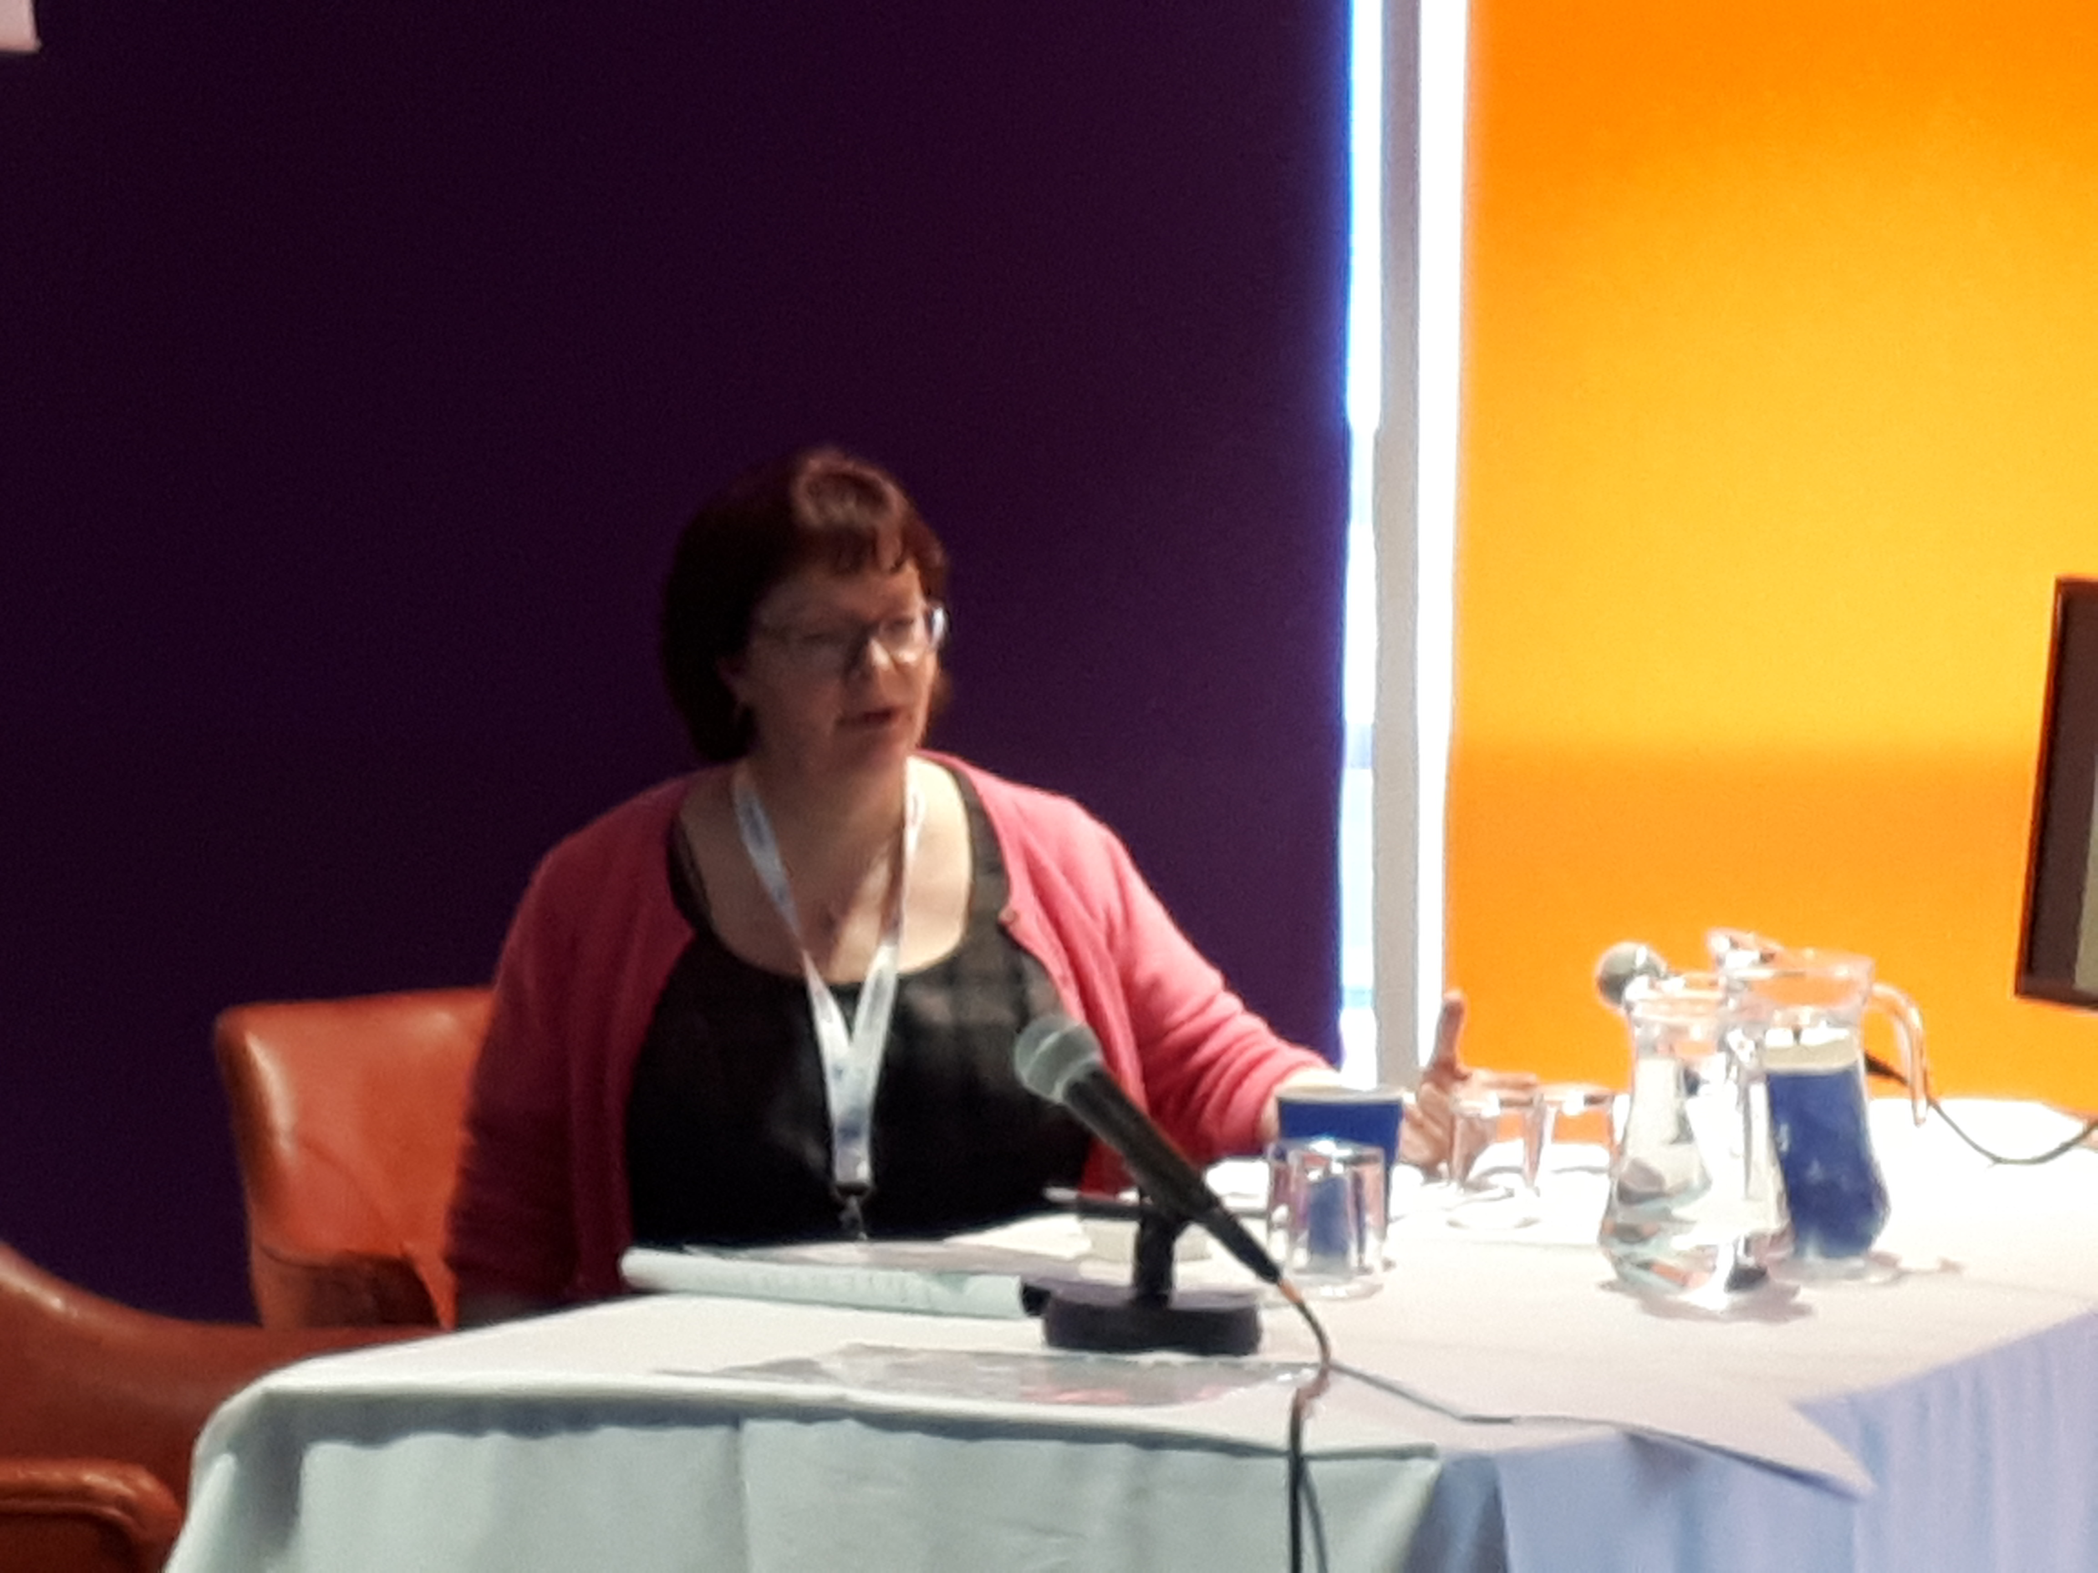

The WHO (2015) defined Health Literacy as “The personal characteristics and social resources needed for individuals and communities to access, understand, appraise and use information and services to make decisions about health”. Mandy explained that for an individual to successfully access health care they must possess functional, interactive and critical skills. It should not be a surprise to us to learn that those with low levels of language and literacy skills fare badly in this regard and have the poorest health outcomes in society. The scale of the problem is astounding, 43% of adults do not have adequate literacy skills to routinely understand health information and 61% of adults do not have adequate numeracy skills to routinely understand health information. Socio-economic deprivation, chronic health and disability along with common medical further disadvantages this part of our society. We as Arthroplasty Care Practitioners can help this proportion of society by understanding this problem, demystifying jargon by helping the system to become better suited to the population and by ensuring that information and services are available to all. For a fuller insight into this subject ACPA urges you to see Mandy Wardle-McLeish’s presentation on our ACPA website. The presentation has been kindly donated to members of ACPA for their personal use in this area. ACPA is extremely grateful to Mandy for bringing this topic to our attention and it believes that we can all learn positively from Mandy and the tremendous work that the CHL foundation undertakes.
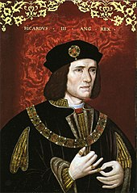
Before lunch BASK and ACPA members were treated to an informative and equally amusing presentation by the Guest Speaker, Biological Anthropologist and Archaeologist, Dr Piers Mitchell. The subject, ‘Musculoskeletal Disease and Trauma in King Richard III, provided a rather terrifying insight into the life and rather brutal death of the Plantagenet king. Richard Plantagenet lived from 1452 to 1485. He ruled England from 1483 until he was killed at the Battle of Bosworth Field, near Leicester, in 1485. His body was buried in the church of the friars minor (Grey Friars), where today evidently stands a Social Services building! In 2012, Richard III remains were excavated from a car park adjacent to the building. Three trial trenches were excavated in one of which was discovered bones. Given the location of the find, the choir of friary, it was thought that the remains would have been from someone important. Unbelievably, the skeletal remains of a young adult male with a spinal deformity and weapon induced injuries, was found only two inches below the hard core of the car park.
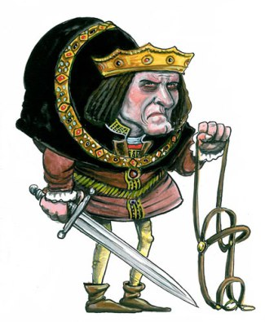Skeletal remains revealed a thoracic scoliosis with asymmetrical vertebrae. The remains were carbon dated and genetic analysis revealed the remains had the same DNA as Richard’s ancestors. All the bones excavated were CT scanned and then reproduced with using a 3D printer. The 3D-printed skeleton was then further analysed and from it the twist in Richard’s thoracic vertebrae confirmed a differential diagnosis of Idiopathic Scoliosis (adolescent onset). Amusingly, William Shakespeare depicted Richard III as having a hunchback a century after the death of Richard. Of course, this was not strictly correct, and perhaps the more accurate depiction came from the historian John Rous (died 1492) who described Richard as having unequal shoulders, higher on the right than the left.
Rather gruesome information was gleaned from closer analysis of the battle injuries Richard sustained. There were at least nine wounds. There was a cut mark on the ninth rib from a dagger blade, there was a blade cut on the mandible, a round dagger entry wound at the top of the skull, as well as a large slice wound to the base of the skull (‘the fatal blow’). So, Richard’s end would not have been pleasant! Samples of pelvic soil and control samples of soil found roundworm that had been spread from faecal contamination of food that had been ingested by Richard III. Certainly, therefore, looking at Richard III helps our understanding of how people lived in the middle ages. Should you wish to visit the remains of Richard III, they are now interred in Leicester Cathedral where they have rested since March 2015.

Following lunch, two instructional sessions followed, firstly it was asked ‘Can we improve outcome of Knee Replacement? the second instructional session concentrated on the subject of periprosthetic joint infection.
Day one closed with the ACPA Annual General Meeting. The AGM report can be found on the ACPA website and includes the details of newly elected officers.

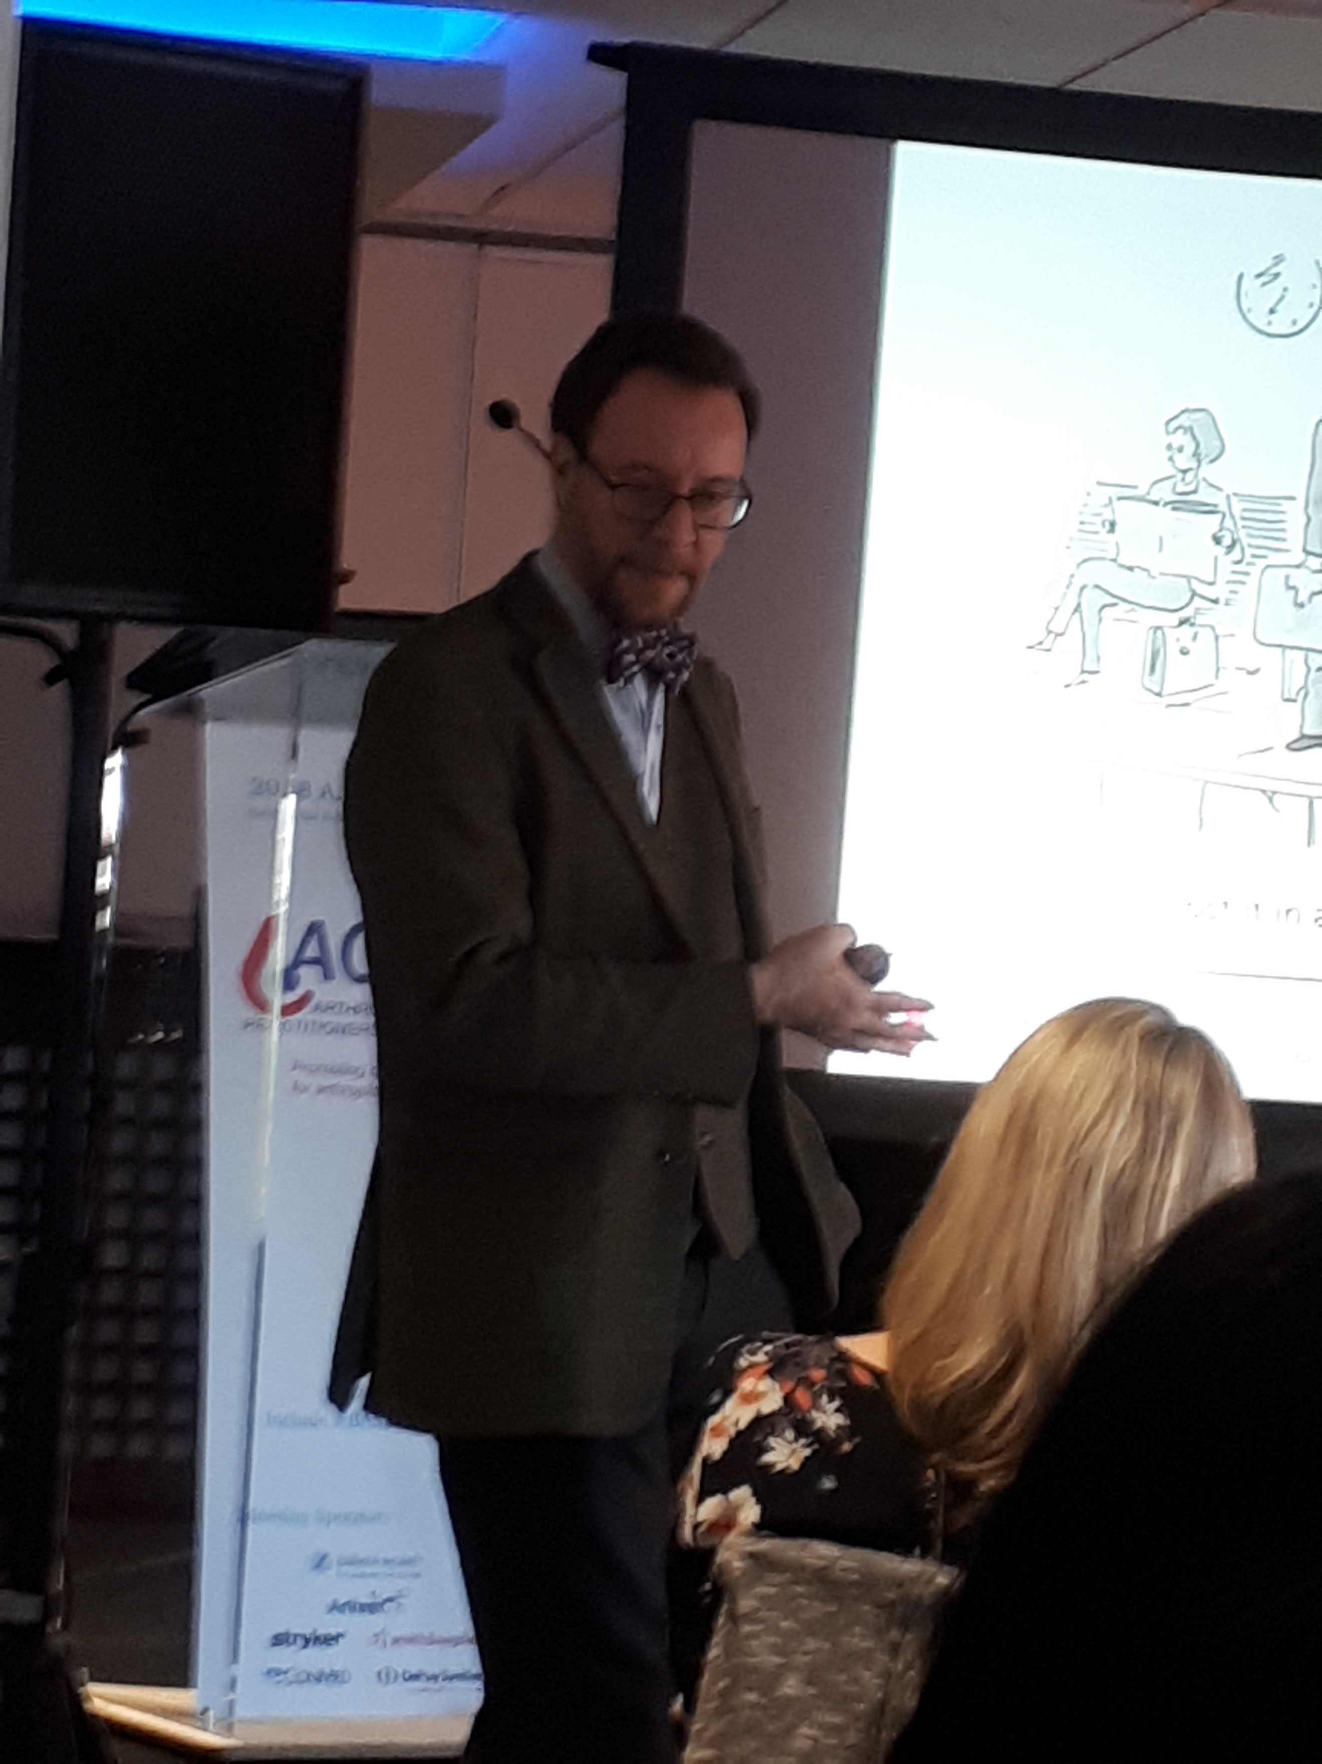
Day two opened with the first of three Clinical Pearls Sessions on A Miscellany of Polyonymous Foot and Ankle Problems given by Mr Stephen Milner, Consultant Foot and Ankle Surgeon at The Royal Derby Hospital. This talk was again extremely informative and entertaining. The presentation itself can be found on the ACPA website with the kind permission of Mr Milner. The talk concentrated on three particular issues from foot and ankle compendium (i) Tibialis Posterior Dysfunction (ii) Charcot Foot (iii) Complex Regional Pain Syndrome). Symptoms, signs, investigations and treatments are discussed in some detail with an emphasis on offering non-surgical management wherever possible. Following the presentation and an enlightening question and answer session ACPA again thanked Mr Milner for his participation and support for our meeting.

The second clinical pearls session was given by Marie Morgan, Clinical Specialist Physiotherapist and Upper Limb Arthroplasty Practitioner at The Royal Derby Hospital.
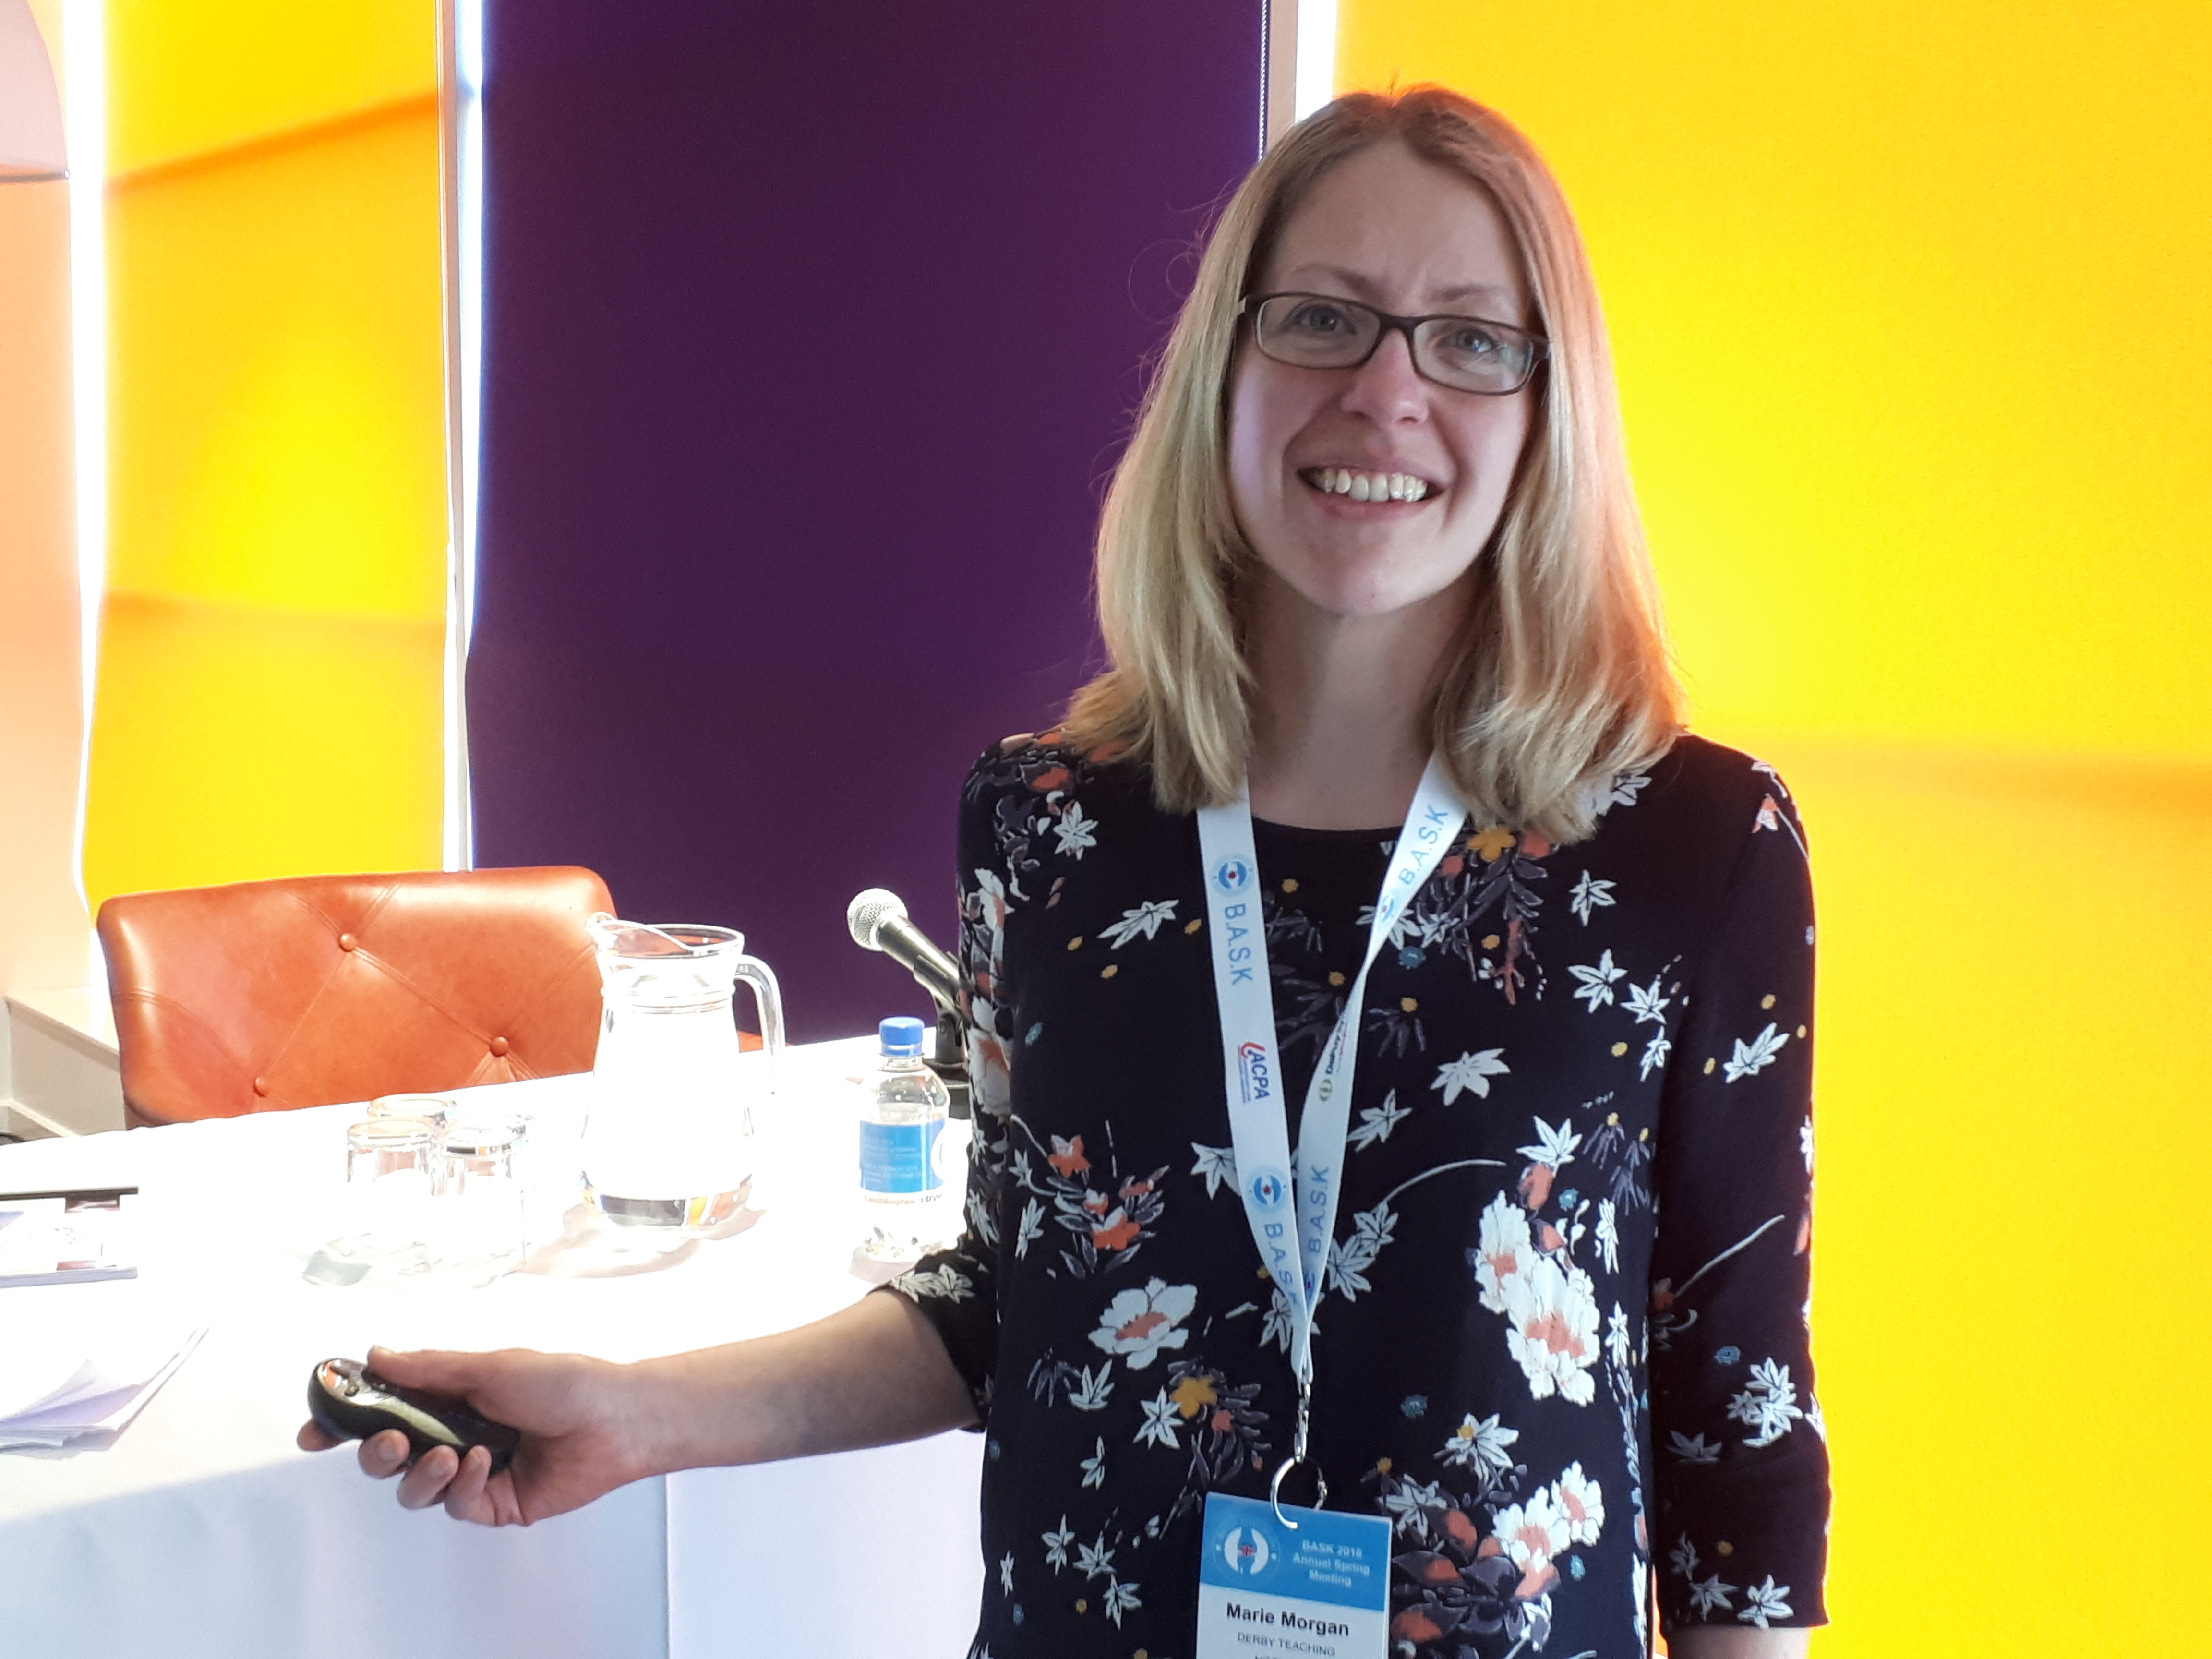
Marie’s presentation on Shoulder and Elbow Placement, included Outcome Measurement and Database Creation. The session detailed Indications for Total Shoulder Replacement vs Reverse Total Shoulder Replacement, Cuff tear arthropathy (CTA) and biomechanics following Reverse Total Shoulder Replacement, Radiographic assessment – Reverse Total Shoulder Replacement and elbow Rehabilitation Pearls. It was not only clear that Marie is very enthusiastic in terms of delivering the best rehabilitation she can for her shoulder and elbow patient’s, but her presentation was able to evidence that she can validate her service and patient outcomes. This is achieved by entering all patients on an established spreadsheet where outcome measurement and satisfaction tools were already agreed by the team involved. Marie stressed engagement with surgeons to find out exactly what they want from the commencement of this monitoring exercise. A minimum dataset can then be established with the aid of IT support. At this point in time the Dataset details over one thousand shoulder and elbow patients and this impressive work continues to evolve. ACPA is very grateful to Marie and her team at Derby for this presentation which can again be found on the ACPA website. Upper Limb Practitioners will find this resource very useful indeed.
The last Clinical Pearls Session was delivered by a very good friend of ACPA, Dr Michael Khoo, Consultant Radiologist, The Royal National Orthopaedic Hospital, Stanmore. Michael stated that around the country Radiology is not routinely taught well and that the majority of us learn ‘on the job’. For this reason he put together his presentation on ‘Back to Basics’ with the aim of understanding the basics of radiology.
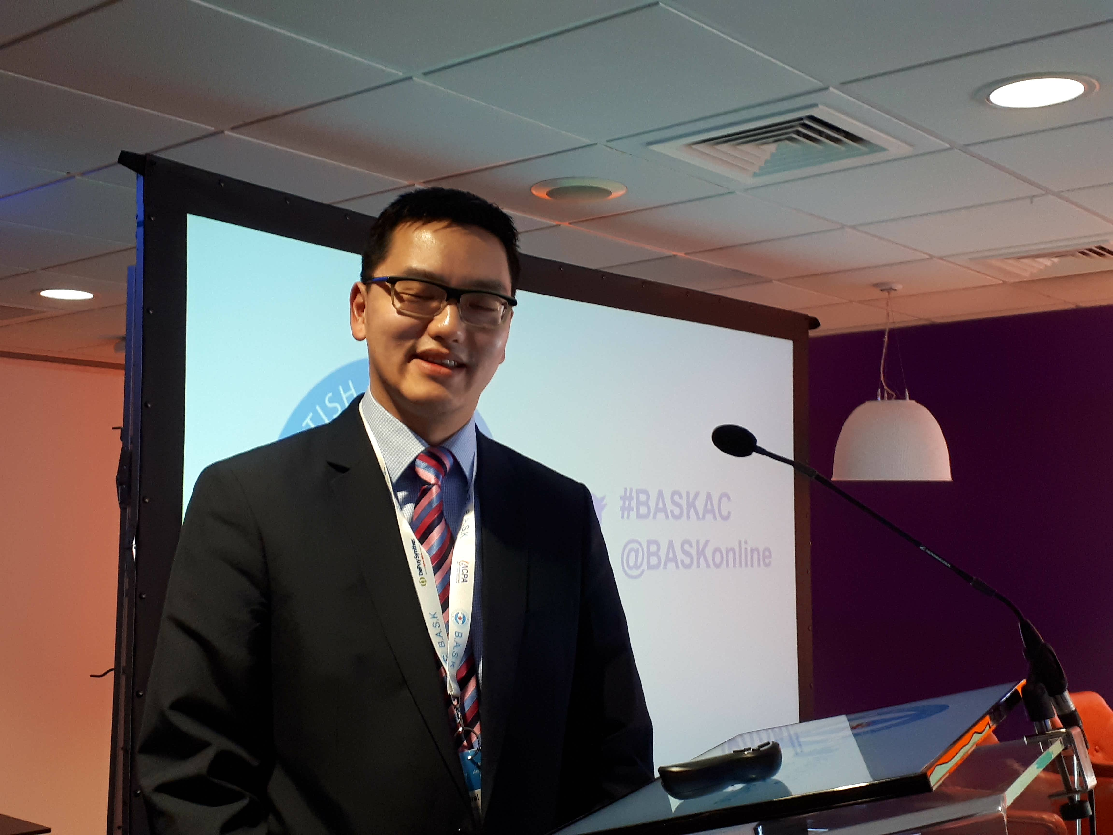
Michael commenced his talk covering the foundations of understanding what can be identified on plain film x-ray through density analysis of the picture – Metal, Bone, Soft Tissue/Fluid, Fat & Air. Michael explained how important the orientation of an x-ray is (AP vs PA), what anatomy can be explained through analysis of the whole picture (and not just an expected area of interest), and the importance of identifying the thoracic ratio (heart size). Radiographic images and explanations of Pneumonia, Pleural Effusion, Pneumothorax and Metastases were given alongside the need to examine the hila region and methodology for examining the skeletal frame.
Of course, in the orthopaedic arena two x-ray orientations or essential so as to not miss abnormalities. Something may look satisfactory in one view but seriously wrong in another. An algorithm for looking at an orthopaedic x-ray was given alongside classification of fractures. Other orthopaedic conditions and images were demonstrated (osteoarthritis, arthropathy, periosteal reactions, fat pad signs, effusions, prosthetic (metalwork) failure and calcification).
Michael then went on to discuss Ultrasound. He informed us that USS is a high frequency sound wave transducer that picks up reflections at tissue interfaces. The Variable received signal produces the image. USS is bad for air/bone but good at identifying fluid/soft tissue. It is safe for patients as no radiation is involved. As such is cheap and safely accessible for certain individuals (young people, pregnancy) but there are limitations as it cannot penetrate air or bone. In orthopaedics it is good for analysis of tendons and joints and for effusions, synovitis, certain masses and vascularity confirmation (DVT). USS is further useful in guided injections and aspirations.
Michael then moved onto CT Imaging. CT is a narrow X ray beam through thin cross-section of body. It is directed through body at multiple different angles. Multiple sensitive detectors measure transmitted X rays on other side of body (similar to film in plain film radiography). Complex mathematical algorithms then compute and reconstruct image based on received Xray data. However, Ionising radiation dose is much higher than plain film x-ray (500-1000 x CxR for one CT abdo/Pelvis) and is as such is prohibited in pregnancy. It is good in visualising osseous anatomy and metalwork and is quick and reliable. In orthopaedics it is useful for assessing osseous condition and components or failure.
For many MRI analysis is perhaps the most puzzling radiological modality. It was useful therefore, for Michael to help elucidate on this subject.
Simply MR images are displayed as two distinct type or images
T1W Images (longitudinal movement of protons) – adding contrast only helps T1 images.
- Fat is seen as bright image (high signal)
- Fluid is dark (low signal) – good to assess Pseudotumours

T2W Images (Transverse movement of protons)
- Fat is still quite bright
- Fluid is bright
MRI is good as it does not use ionising radiation but contrast (gandolinium can be nephrotoxic). The strong magnetic field created by MRI makes it not useful for certain patients (pacemekers, surgical clips, neurostimulators etc). whilst there are limitations MRI does have excellent image resolution, so soft tissue injuries (ACL, Rotator Cuff, Meniscal injury) are well visualised.
Lastly, Michael touched on the subject of Nuclear Medicine. This uses radiopharmaceutical tracers (Technicium Phosphate) to demonstrate osteoblastic activity or occult fractures. However, it was added that new SPECT-CT, which combines a bone scan and CT, brings the best of both modalities. It produces clear high quality reliable imaging.
Michaels presentation is also available for reference on our ACPA website. ACPA thanks him once again for his continued support and considerable experience in his chosen field of expertise.

The ACPA meeting closed following the Open Forum and Networking Session. This session was chaired by Sharon Ferndinadus. These sessions are the chance for all members to bring a subject to the table for open discussion. It is a great opportunity to learn and understand what takes place in other centres and should be viewed as such.
In this session Day Case Arthroplasty, a term shipped over from the USA, was seen as occurring in a couple of centres now in the UK. The term ‘Day-Case’ is variable but enhanced recovery supports this notion. In Oxford there is now a programme day case Unicompartmental Knee Replacement within the NHS setting and this subject was presented in the main BASK session this year. It was added that Total Hip Replacement via a Direct Anterior Approach was also being undertaken at Cardiff by a single surgeon, this emulates growing practice in the USA and Europe.
The session then went on to discuss Infection control modalities and practice around the country and it is clear that no one specific recommended practice is undertaken. Practice differs also in post-discharge follow up/support. In Birmingham (Royal Orthopaedic) a ‘ROCKS’ team can support patients at home, by assessing wounds in an attempt to stop overprescribing of antibiotics by general practitioners. Physio follow-up can also be instigated. Allied to this subject pre-op washing was discussed, Jenny Watson (ACPA Treasurer) stated that in Sheffield arthroplasty patients are provided with and instructed to wash/shower with ‘hibiscrub’ five days before surgery and to use a specific shampoo. Some centres reported only showering on the day of surgery, some centres had no protocol at all.
ACPA will look to keep this session in place for future meetings and would welcome its members to think about subjects that they would want discussed in this forum. Equally, any subject can be posted on the ACPA website discussion page. This would then be shared with the ACPA community to everyone’s benefit.
This years’ meeting was closed by Mark Goodson. He thanked Claire Stevens and the BASK and venue technicians for their efforts in putting together such an excellent and enjoyable meeting. He wished everyone a safe journey home and looked forward to seeing as many ACPA members as possible in Nottingham BHS/ACPA combined meeting March 2019.

Mark Goodson
President – Arthroplasty Care Practitioners Association

