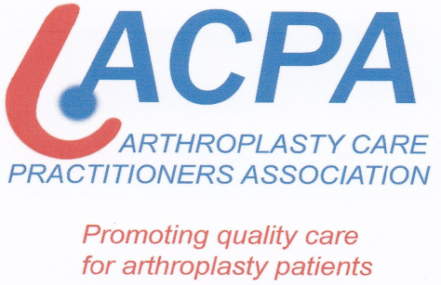
ACPA CONFERENCE PARALLEL TO BASK ANNUAL SPRING MEETING
LCFC, King Power Stadium, Leicester
20th – 21st March 2018
ALL ACPA DELEGATES MUST REGISTER AND PICK UP LANYARD FROM MAIN BASK DESK BEFORE GOING TO SECOND FLOOR. The APCA Meeting is being held in Premier Lounge 2, Second Floor.
Tuesday 20th March
08.00 REGISTRATION & COFFEE – Reception Lounge & Walkers Hall within the Exhibition Area
09.00 WELCOME & INTRODUCTION – BASK President, Colin Esler (Leicester) – Keith Weller Lounge
09.30 WELCOME & INTRODUCTION TO MAIN ACPA PROGRAMME – Clare-Louise Sandell, ACPA President, Premier Lounge 2, Second Floor
09.40 GiRFT – THE ROLE OF THE ARTHROPLASTY PRACTITIONER IN VALIDATING DATA – Mr Tim Wilton, Consultant Orthopaedic Surgeon, Royal Derby Hospital, Derby, UK
10.15 COFFEE – (Walkers Hall & Reception Lounge – Exhibition/Poster & E-Poster Viewing)
10.45 HEALTH LITERACY & NUMERACY – AN INTRODUCTORY AND INSTRUCTIONAL SESSION ON KEY CONCEPTS FOR ENHANCING PATIENT CENTRED COMMUNICATION AND CONSENT – Ms Maxine Dennis, Operations Director, Community Health & Learning Foundation, Loughborough, UK
12.45 MAIN BASK PROGRAMME – GUEST SPEAKER: Piers Mitchell (Peterborough) Presentation “Richard III”
13.15 LUNCH – (Walkers Hall & Reception Lounge – Exhibition/Poster & E-Poster Viewing)
14.00 MAIN BASK PROGRAMME – INSTRUCTIONAL SESSION 1 – Can we improve outcome of knee replacement?
15.20 TEA – (Walkers Hall & Reception Lounge – Exhibition/Poster & E-Poster Viewing)
15.50 MAIN BASK PROGRAMME – INSTRUCTIONAL SESSION 2- Periprosthetic Joint Infection
17.15 – 18.15 ACPA AGM & DRINKS RECEPTION
19.30 for 20.15 – Annual Dinner, ‘The National Space Centre’ Leicester. There will be an alternative ACPA dinner – venue to be confirmed.

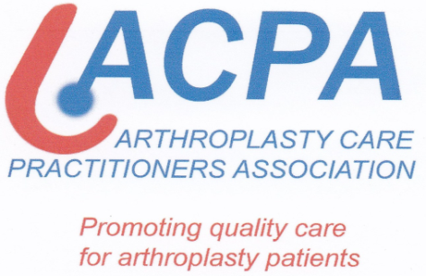

ALL ACPA DELEGATES MUST REGISTER AND PICK UP LANYARD FROM MAIN BASK DESK BEFORE GOING TO SECOND FLOOR. The APCA Meeting is being held in Premier Lounge 2, Second Floor.
Wednesday 21st March
08.00 REGISTRATION & COFFEE – Reception Lounge & Walkers Hall within the Exhibition Area (Poster & E-Poster Viewing)
09.00 CLINICAL PEARLS SESSION 1 – FOOT AND ANKLE – Mr Stephen Milner, Consultant Foot and Ankle Surgeon, Royal Derby Hospital, Derby, UK
09.30 CLINICAL PEARLS SESSION 2 – SHOULDER AND ELBOW REPLACEMENT, INCLUDING OUTCOME MEASUREMENT AND DATABASE CREATION – Ms Marie Morgan, Clinical Specialist Physiotherapist and Upper Limb Arthroplasty Practitioner, Royal Derby Hospital, Derby, UK
10.05 COFFEE – (Walkers Hall & Reception Lounge – Exhibition/Poster & E-Poster Viewing)
10.40 CLINICAL PEARLS SESSION 3 – RADIOLOGY: BACK TO BASICS – Dr Michael Khoo, Consultant Radiologist, Royal National Orthopaedic Hospital, Stanmore, UK
12.00 MAIN BASK PROGRAMME – Lorden Trickey Lecture- Principles of Revision Knee Arthroplasty, Dr Wolfgang Klauser, Hamburg, Germany
12.40 LUNCH – (Walkers Hall & Reception Lounge – Exhibition/Poster & E-Poster Viewing)
13.20 ACPA OPEN FORUM AND NETWORKING SESSION – Chaired by Sharon Ferndinadus, Orthopaedic Nurse Specialist, Chapel Allerton Hospital, UK
15.00 ACPA MEETING ENDS AND CLOSING REMARKS
15.10 COFFEE – (Walkers Hall & Reception Lounge – Exhibition /Poster & E-Poster Viewing)
15.30 MAIN BASK PROGRAMME
16.30 Closing Remarks– President, Colin Esler (Leicester)
16.45 Close of the ‘2018 BASK Annual Spring Meeting’

