

The Arthroplasty Care Practitioner’s Association

Lindsay K. Smith PhD, MSc, MCSP

The Arthroplasty Care Practitioner’s Association (ACPA) represents a multidisciplinary group of advanced health professionals who are involved in the care of patients with a joint replacement. They may provide care at one or more points in the pathway which commences at referral for surgery, continues through pre-operative screening, peri-operative care and discharge, and goes all the way to long term follow up.

History
Early in 2005, any non-medical health professional involved in arthroplasty was invited to attend the British Hip society (BHS) meeting at Wrightington. This led to the formation of a steering group that identified the lack of standardisation of arthroplasty follow up across the UK at that time. The fledgling Arthroplasty Care Practitioner’s Association was launched at the 2006 BHS meeting in Edinburgh in order to provide an umbrella network for health professionals to work together with each other and with the orthopaedic surgeons in order to improve the process of arthroplasty review.

The founding constitution of ACPA included the following aims:

- To provide a forum for discussion of the development of a national standardised programme of joint replacement follow-up.
- To support joint registries including the National Joint Register (NJR) and the Scottish Arthroplasty Project (SAP)
- To work with the British Orthopaedic Association (BOA) and associated specialist societies to achieve common goals.
- To support training of Arthroplasty Care Practitioners through education including training at the national meeting.
- To promote research into joint replacement

There has been considerable progress since the inaugural meeting including a formal affiliation to the British Orthopaedic Association (BOA). The BOA and the specialist societies, BHS and BASK (British Association for Surgery of the Knee), have been very supportive of our members and have been extremely generous in sharing their annual conference facilities with ACPA. This had facilitated interaction and discussion between surgeons and ACPA members that has been mutually beneficial.

In addition, ACPA has gone on to develop courses and define competencies for members in conjunction with established universities and the BOA. The annual meeting provides members with the opportunity to hear key speakers present on current topics and to network with other members across the UK in order to share practise.

Current
The current professional mix includes physiotherapists, orthopaedic nurses, surgical care practitioners, radiographers and an occupational therapist. All of these health professionals are working at an advanced level, many having completed master’s degrees. They retain their profession specific status but work as part of the orthopaedic team linked directly with the surgeons and very often trained by them.

The development of this role is not limited to the UK but is also taking place elsewhere. We have had practitioners from Canada and Australia attend courses that we have provided and visit units where arthroplasty practitioners are in place. This had led to some international exchange that has potential for future networking.

Clinical models
There are a number of different models of arthroplasty surveillance in place across the UK, each having arisen in response to the local need. In some centres, practitioners may be involved in pre-surgery screening; some will have practitioners present at surgery, particularly those with a background as a theatre nurse or surgical care practitioner. Some centres employ practitioners to assist the surgeons on the wards in early post-operative monitoring and preparation for discharge. Many centres employ them to provide the after care service, including the use of a telephone help line for patients and GPs, and the long term follow up is usually provided by practitioners with support from the consultants when required.

Although the traditional model of long term follow up has been a clinical review, some hospitals are now moving to a mix of virtual surveillance and clinics. This can provide a better use of scarce resources but as yet, we have no clear evidence to suggest which patients should be seen and which can be reviewed virtually. However, we also lack evidence for our traditional clinical approach, much of what is done being historical and based on surgeon preference. There is no doubt that advice from orthopaedic surgeons with a wealth of experience is of tremendous benefit but there is also a need for good quality research to determine a gold standard for arthroplasty surveillance.

Competency
The skills needed by an arthroplasty practitioner will be determined by their role within the arthroplasty pathway. As with many other advanced practitioner roles, the skills have traditionally been taught by committed local medical staff who have recognised a need and identified a health professional with the ability to meet the need. These professionals retain all their profession specific skills but add to them in order to expand their role. The problem with this approach is that the advanced practitioner has difficulty in demonstrating the development of their skills if transferring to a job elsewhere.

In 2010/11, ACPA worked with Peter Kay (then President of the BOA), the Department of Health, Skills for Health, the major professional bodies and a higher education institute in order to define the competencies required for a practitioner in each part of the arthroplasty pathway. The documents produced were based on those used in medical training to show evidence of procedural skills. This was a major step forwards in making the arthroplasty practitioner role a transferable skill within the UK. The documents are available from the ACPA website (www.acpa-uk.net) and provide a useful checklist for any surgeon wanting to employ or train a practitioner locally. There is one for each of four areas of the pathway: pre-operative, peri-operative, early post-operative and long term follow up.

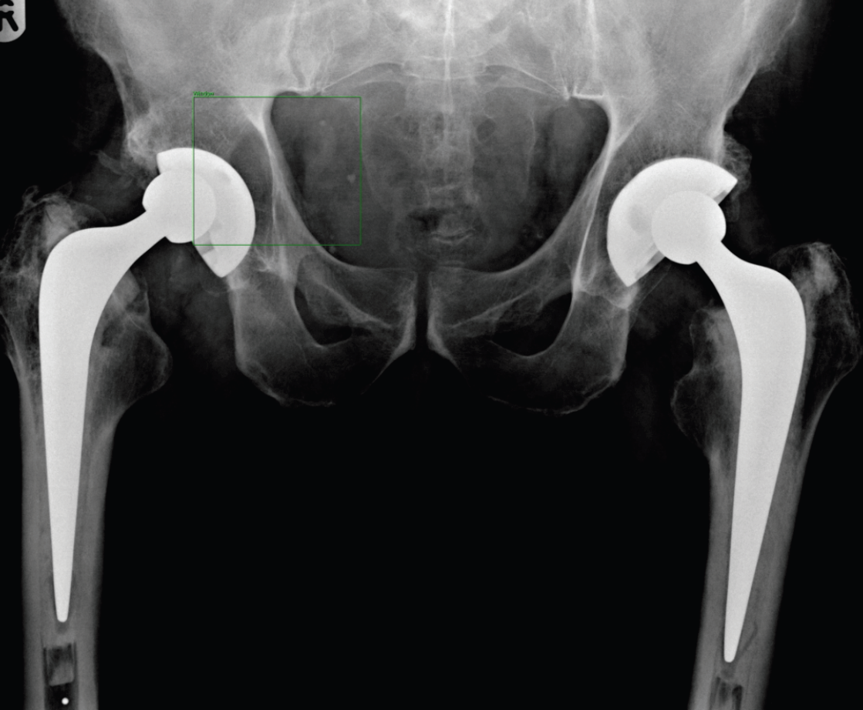

Figure 1. AP pelvic view of active 74 year old male with silent osteolysis behind right hybrid hip replacement of 10 years, identified through arthroplasty review clinics and successfully revised.

Financial crises
Although there is no doubt about the benefit of surveillance within the orthopaedic community, the current economic situation is widely affecting these services. Some Trusts are finding themselves forbidden to offer follow up beyond a 6 week post-operative check. In such times, it is imperative that we collect the evidence to show the benefit to patients and to the NHS of periodic review. This will involve examining different models of delivery and the essential time periods for review, as well as the effect of surveillance on the costs of revision surgery. The financial crisis may well be the catalyst for research to support an evidence-based practice approach to arthroplasty surveillance.

Future
ACPA will continue to work with the surgeons and other bodies to develop the processes of review and to support new practitioners and those that are in role. They provide a stable element to the team with a good working knowledge of their surgeons’ practise and extensive problem solving skills as a result. They have the flexibility to be able to deliver the service in a variety of locations but to retain the crucial link to the surgeon. As such, they provide the surgeon with feedback and confidence in his/her arthroplasty practice.

Enquiries
Via ACPA website www.acpa-uk.net or info@acpa-uk.net

