## 

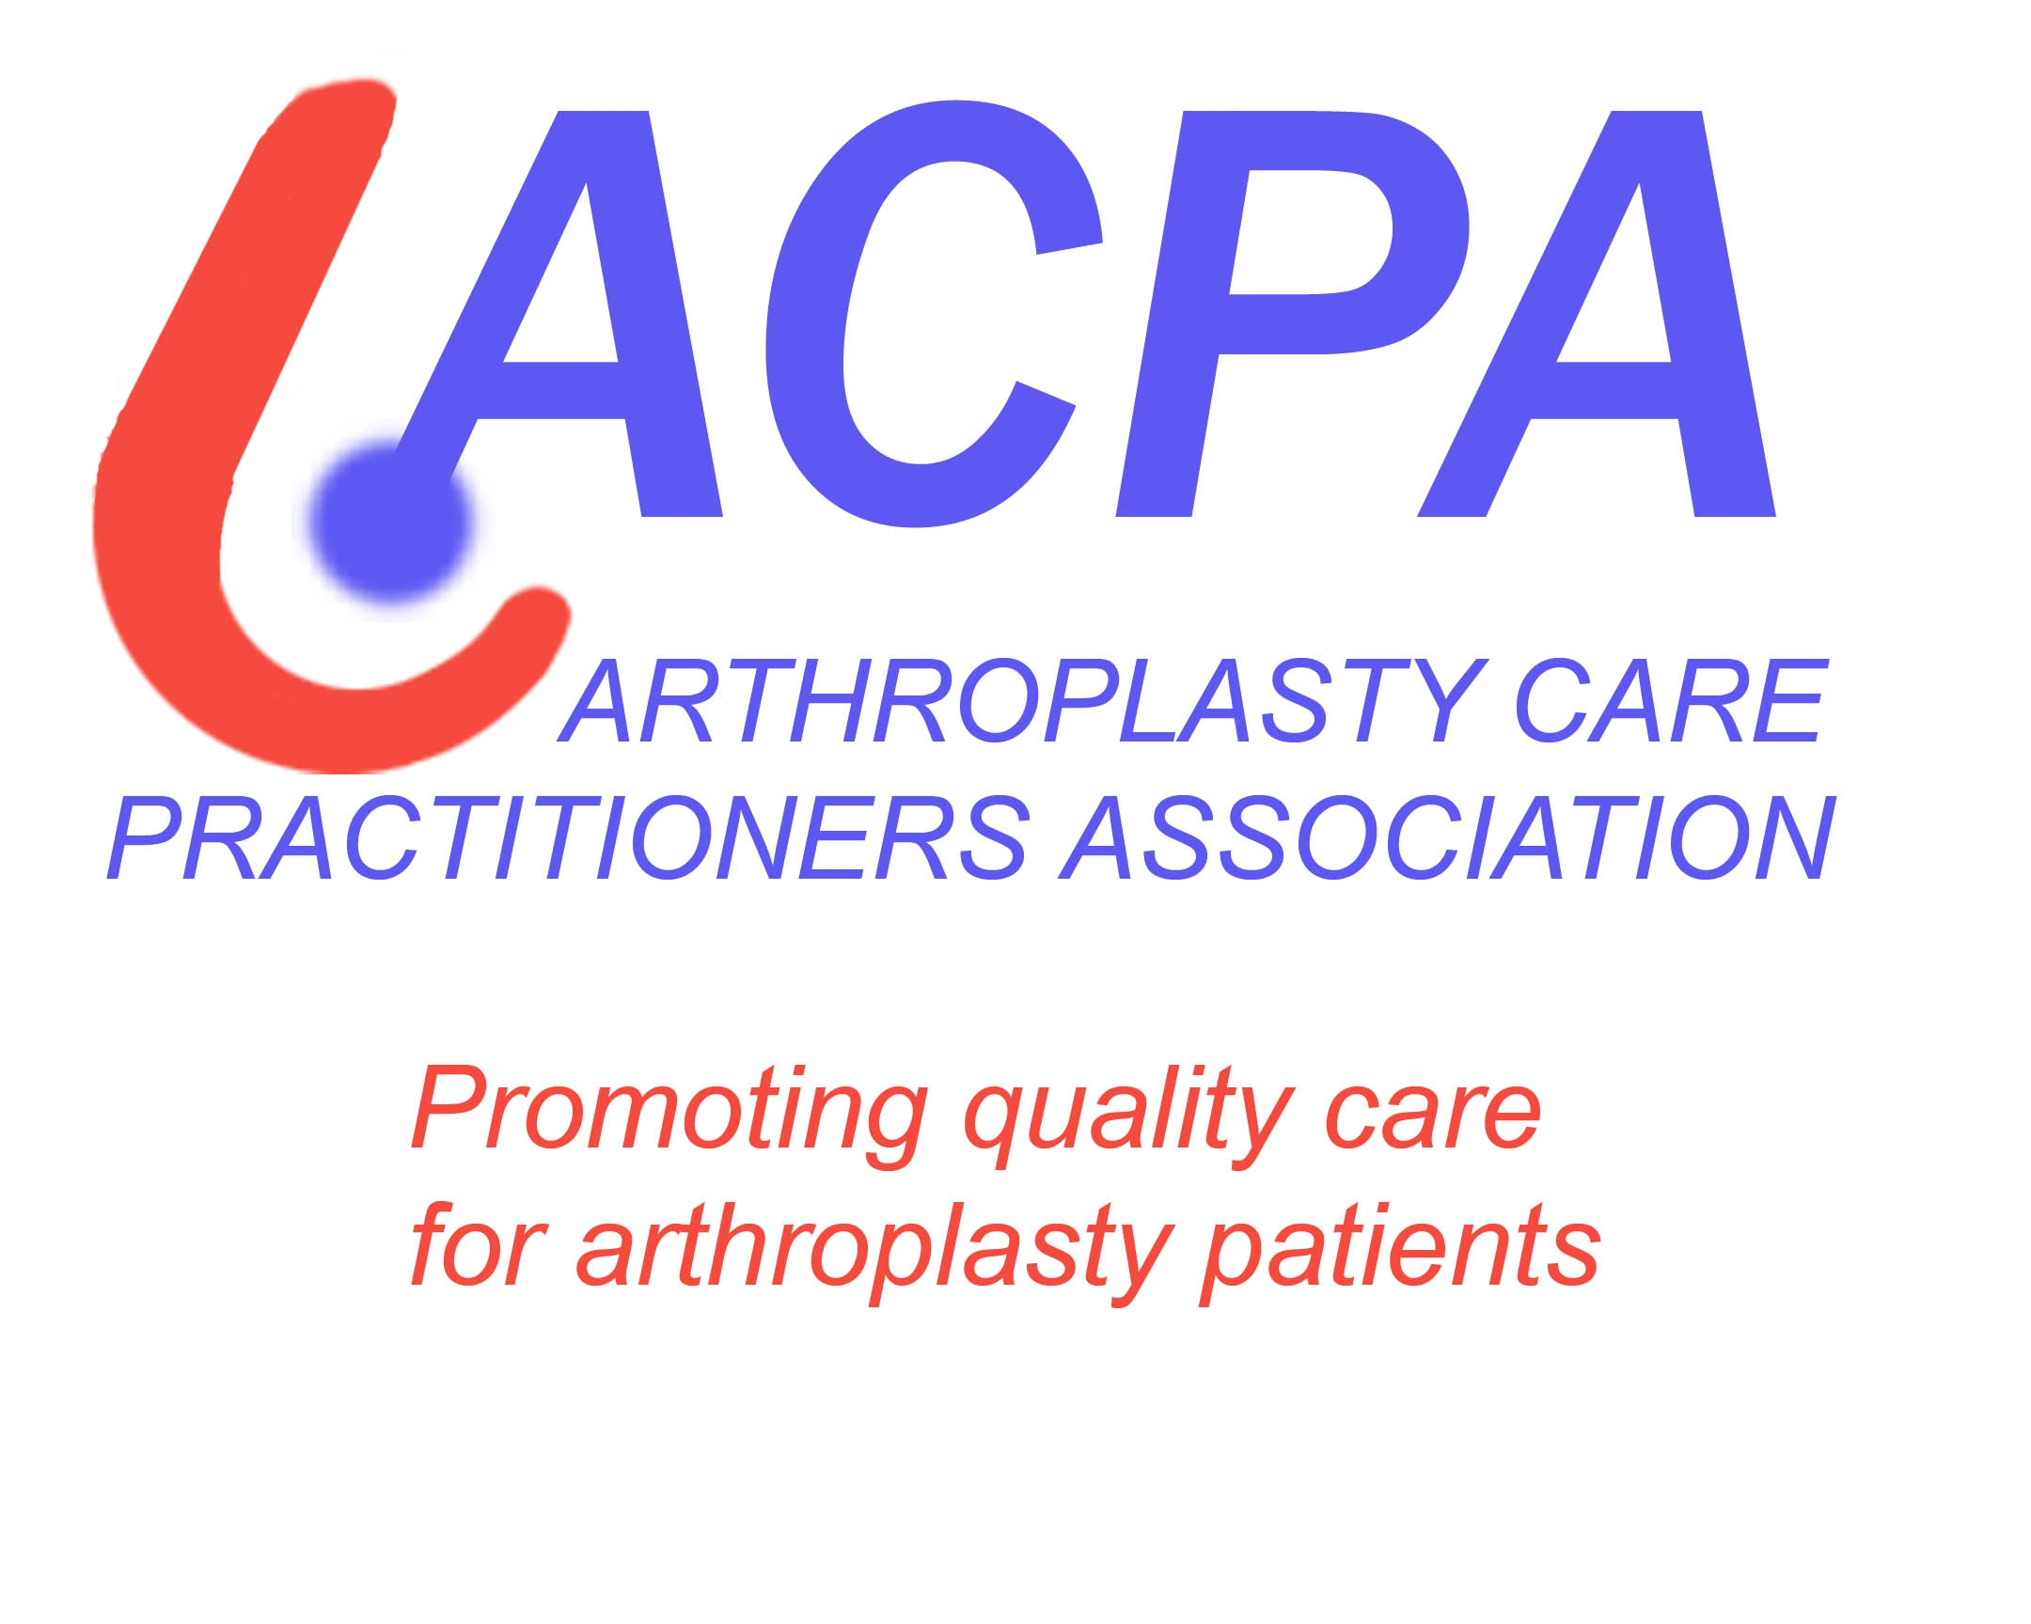

***CONTACT US AT:***

***acpa-uk@hotmail.com***

**2015 Will Be The ACPA10 Year Anniversary And We Aim To Celebrate**

**Why not join the ACPA committee?**

**Contact us to shape the associations future, & at the forefront in sharing best practice. Be a leader of arthroplasty care developments and work in partnership with other professional organizations.**

[**Jill.pope@rlbuht.nhs.net**](mailto:Jill.pope@rlbuht.nhs.net)[**clare.sandell@iow.nhs.uk**](mailto:clare.sandell@iow.nhs.uk)

**ACPA Provides**

* **Networking opportunities**
* **Study days & conferences**
* **Information on Prosthesis**
* **Job opportunities**
* **Access to PowerPoint presentations**
* **Support & Friendship**
* **Opportunities to showcase your work**
* **Opportunities to present at meetings**
* **Web links to NJR, James Lind Alliance & practical hip and knee examination**
* **Reduced rates for some courses and conferences**

**2015 Dates for your diary**

* **BOA Congress** Liverpool 15th to 18th September 2015
* **Biomechanics course** TBC
* **Surgical skills course** TBC

**MAY 2015**

**WE STILL WANT**

**Business case examples** for members to access on the members area of the website to share resources and ideas. Ideas to Lindsay Smith [**smith@unforgettable.com**](mailto:smith@unforgettable.com)

**Upper limb**  information or help that we can give to colleagues working within upper limb. Please contact us with any innovation or updates via [**Jill.pope@rlbuht.nhs.net**](mailto:Jill.pope@rlbuht.nhs.net)

**Telephone follow up :**memberswith experience of telephone follow up please share your experience with us via [**clairestevens@nhs.net**](mailto:clairestevens@nhs.net)

**BASK SPRING MEETING 2015**

The BASK Spring meeting was held in the International Centre, Telford on 10th and 11th March. Out of nine free paper sessions one focused on Uni-compartmental KR, two focused on primary arthroplasty and one on revision surgery, whilst other sessions also included presentations reporting on arthroplasty studies so there was much to interest the arthroplasty practitioners who attended. However the early presentations were marred by the poor acoustics

A highlight of the first day was a mock trial of a Clinical Negligence Case with a lively report from the ‘claimant expert witness’ and an equally lively defence from the ‘defendant witness’.

The Annual Dinner was held in the splendid setting of Hangar 1 at RAF Cosford. It was a little surreal to have an excellent three course dinner surrounded by vintage aeroplanes.

On the second day a thought provoking session on registries was followed by the keynote ‘Lorden Trickey Lectire’ given by Prof. Dr Hermann Mayr, President of the German Knee Society, on ‘The Stiff Knee’.

There were more than fifty posters and sixty e-posters, as well as trade stands, to provide interest during lunch and coffee breaks.

The varied and stimulating programme and good discount rate for ACPA members made this meeting well worth attending.



**Questions about early osteoarthritis of hip or knee?**

**We want to hear from you!**

**Who can take part?**

***Patients, carers, and healthcare professionals***

If you have (or have had), or are caring for someone who has (or has had) early stage osteoarthritis (OA), **or** work as a health or social care professional with people who have (or have had) early stage OA ***. . . we want to hear from you.***

**Why should I take the survey?**

The **Early OA of Hip and Knee** survey will - for the first time - identify your most pressing unanswered questions about the diagnosis, surgical and non-surgical treatment, and likely outcomes of early OA of hip and/ or knee. This will ensure that future research can be prioritised according to the needs of patients, carers and health professionals. This exciting initiative will be overseen by The James Lind Alliance, a non-profit making organisation funded by the National Institute for Health Research, ensuring the exercise produces an unbiased result, with equal weighting given to the views of the different participating groups. So whether your interest is personal or professional …your opinions will count.

**How do I take part?**

The survey is available [https://www.surveymonkey.com/r/FDL95LR](https://www.surveymonkey.com/r/FDL95LR%20) or contact the James Lind Alliance Project Manager at the Oxford Biomedical Research Centre to request a paper version (tel / voicemail 01865 223298, e-mail sandra.regan@ouh.nhs.uk).

***The survey takes about 10 minutes to complete, so please take this opportunity to influence the future of early OA of hip and knee.***

**Research Request**

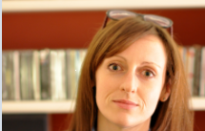

'Amy Grove at Warwick Medical School, The University of Warwick, has been awarded funding from the National Institute for Health Research for three years to investigate the changing use of evidence in orthopaedic practice.  During the research Amy is working alongside orthopaedic teams in England to examine the 'real life’ understanding, uptake and use of evidence in the field of arthroplasty. She is conducting informal interviews with a range of clinical, clerical and managerial staff to obtain a full picture of what happens within the NHS. If you would like to share your views on this topic please contact Amy by email: [A.L.Grove@warwick.ac.uk](mailto:A.L.Grove@warwick.ac.uk) or telephone 02476 151584, 07779 612101 she would really value the opinions from members of the Arthroplasty Care Practitioner's Association as they play a key role in delivering orthopaedic services to patients'

**NB To get the most out of your membership, make sure you send us information or suggestions for discussions or sessions that should be included at future events. Renewal is in October & remains £30 Please inform Anne Bradley if you pay on line.**