## 

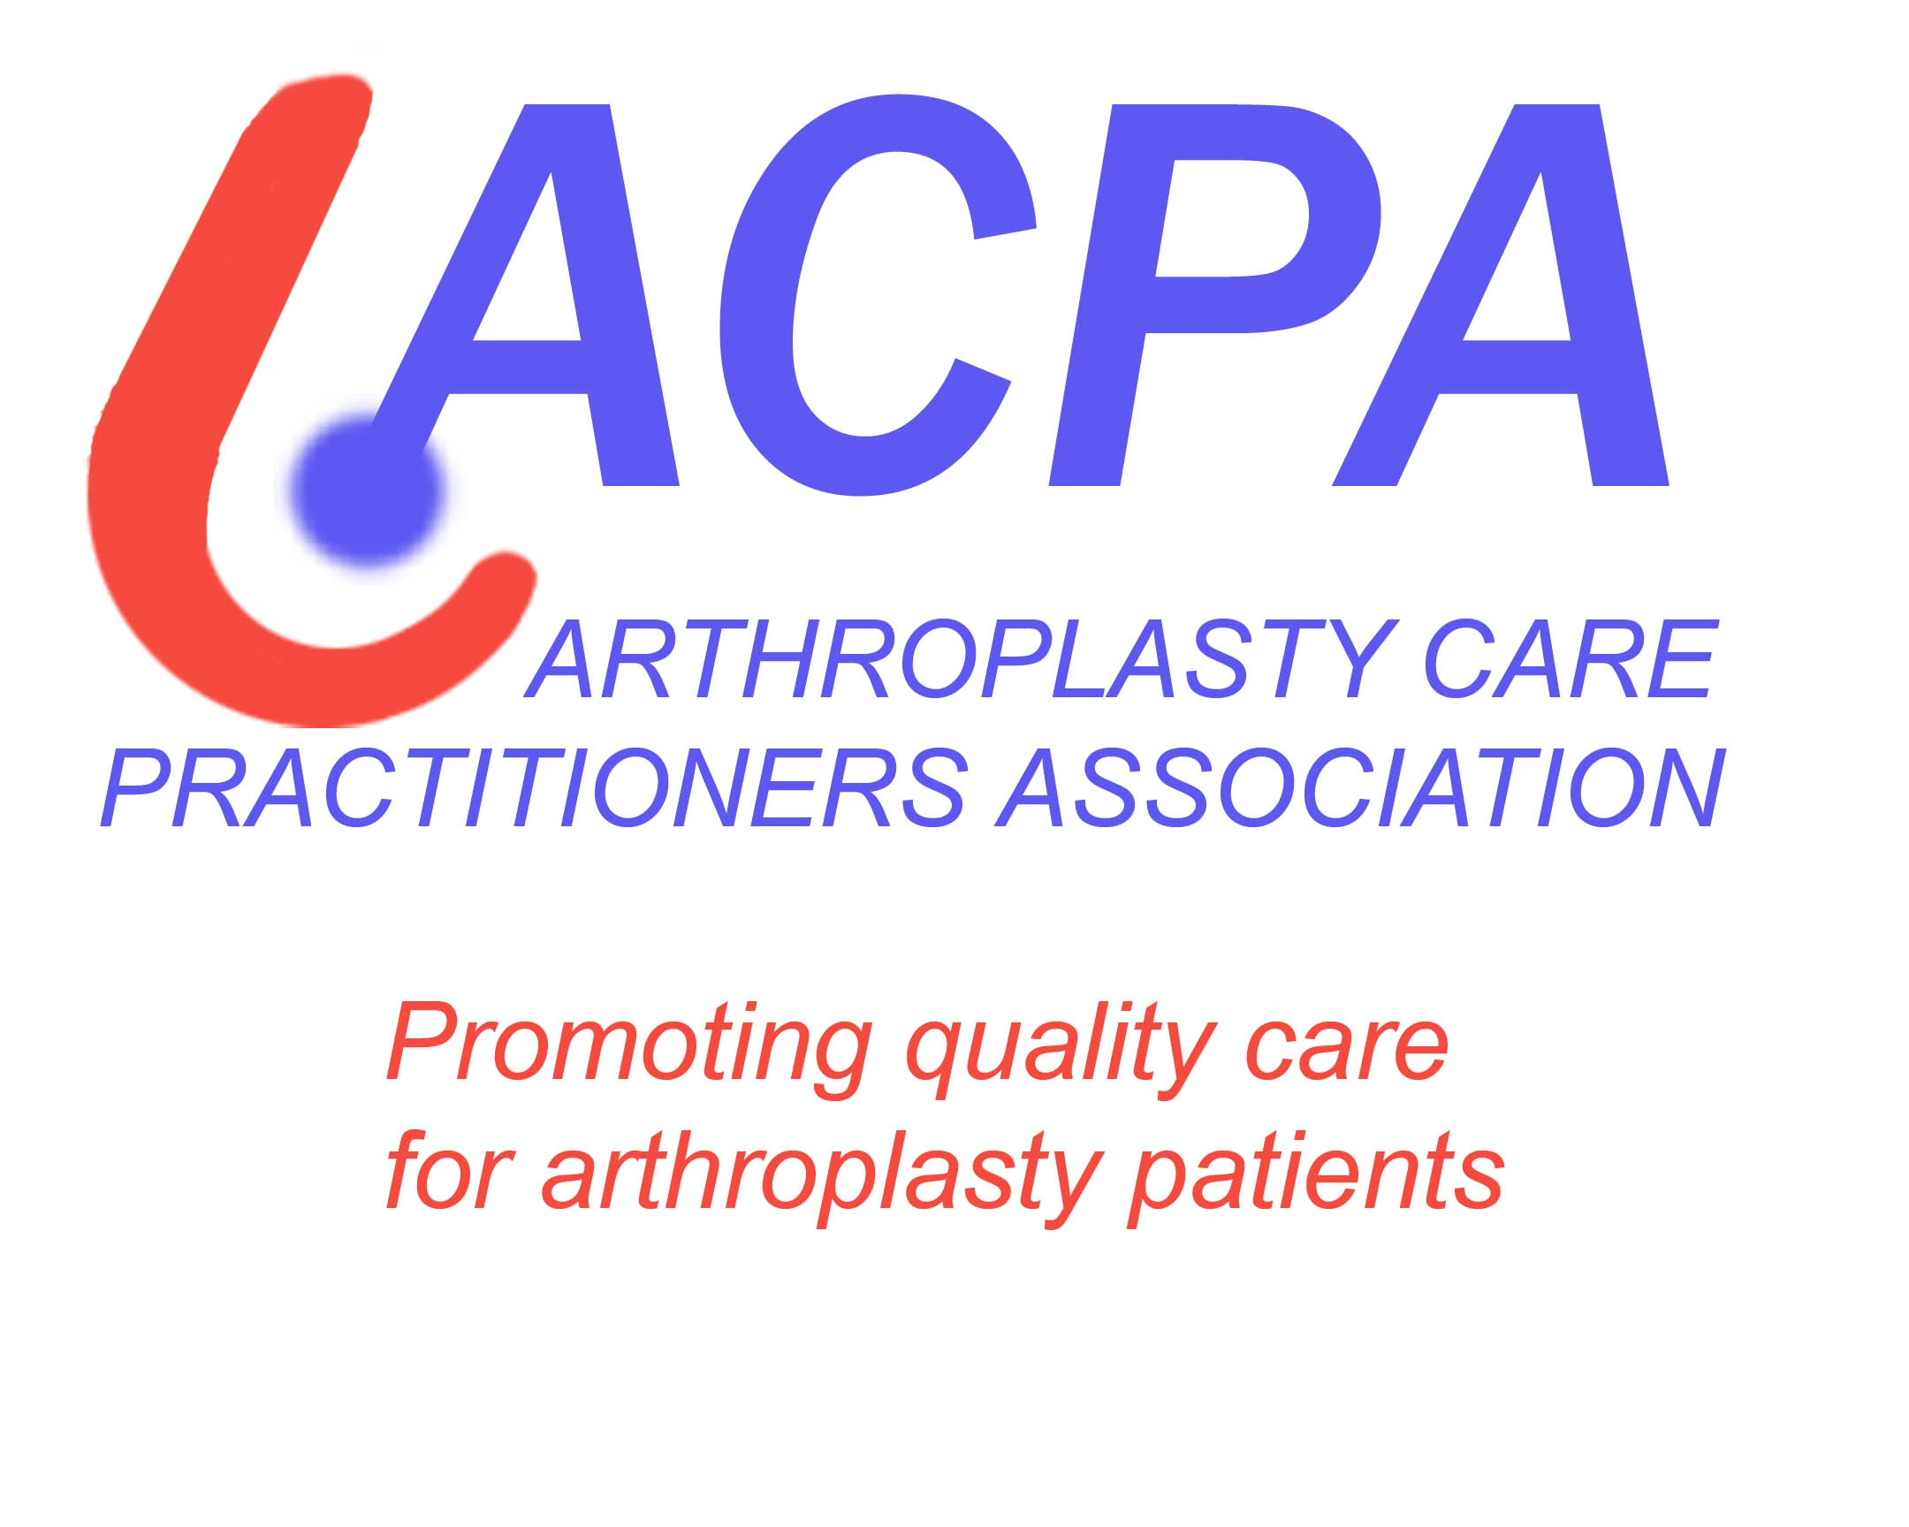

***Happy New Year From ACPA***

***2015***

***acpa-uk@hotmail.com***

**2015 will be the ACPA 10 year anniversary and we aim to celebrate & promote this milestone throughout the 2015 conference.**

**Why not join the ACPA committee?**

**Contact us to shape the associations future, & at the forefront in sharing best practice. Be a leader of arthroplasty care developments and work in partnership with other professional organizations.**

[**Jill.pope@rlbuht.nhs.net**](mailto:Jill.pope@rlbuht.nhs.net)[**lesley.hugill@uhcw.nhs.uk**](mailto:lesley.hugill@uhcw.nhs.uk)

**ACPA Provides**

* **Networking opportunities**
* **Study days & conferences**
* **Information on Prosthesis**
* **Job opportunities**
* **Access to PowerPoint presentations**
* **Support & Friendship**
* **Opportunities to showcase your work**
* **Opportunities to present at meetings**
* **Web links to NJR, James Lind Alliance & practical hip and knee examination**
* **Reduced rates for some courses and conferences**

**2015**

**BHS/ACPA** Come and join usbeing a member of ACPA allows you to attend this fantastic conference at reduced rates the combined meeting will be held in London (Stanmore) 2nd & 3rd March 2015. check the ACPA web site for further details.

**2015 Dates for your diary**

* **BHS/ACPA 2nd & 3rd** March.
* **BASK** is calling for papers for the 2015 meeting in Telford 10th & 11th March. Abstracts on line submission from 1st Sept to 14th Nov 2014.
* **BOA Congress** Liverpool 15th to 18th September 2015
* **Biomechanics course** TBC
* **Surgical skills course** TBC

**Lindsay Smith** is reviewing the image interpretation competencies;

**Morag Trayner** will be investigating the possibility of ACPA publishing a report from the Scottish Arthroplasty Project.

***check the web site and future bulletins for further information****.*

**2014 Awards/Achievements**

**IN BRIEF**

**Congratulations to Jane James & team for their publication** V. Kumar S. Sharma J. James J.P Hodgkinson & M.V. Hemmady. Total hip replacement through a posterior approach using a 22mm diameter femoral head: The role of the transverse acetabular ligament and capsular repair in reducing the rate of dislocation. Bone Joint J September 2014 96-B:1202-1206

**WE STILL WANT**

**Business case examples** for members to access on the members area of the website to share resources and ideas. Ideas to Lindsay Smith [**smith@unforgettable.com**](mailto:smith@unforgettable.com)

**Upper limb**  information or help that we can give to colleagues working within upper limb. Please contact us with any innovation or updates via [**Jill.pope@rlbuht.nhs.net**](mailto:Jill.pope@rlbuht.nhs.net)

**Telephone follow up :**memberswith experience of telephone follow up please share your experience with us via [**clairestevens@nhs.net**](mailto:clairestevens@nhs.net)

The ‘Getting it right first time’ (**GIRFT**) report published by Professor Briggs in late 2012, give guidance and usefull information regarding England’s orthopaedic surgery provision &improve; pathways of care, patient experience, and outcomes with significant cost savings. It suggests this approach has the potential to deliver a timely/cost effective improvement in the standard of orthopaedic care across England. Currently visits are taking place across the country please share your experiences with us.

**BASK/ACPA Annual Meeting April 2014 -**

A varied programme with the choice of choosing ACAP or main meeting. Excellent speakers from consultants, Nurses and Physios & updates regarding the NJR/PROMs & BPT, virtual clinics, and how we as ACPA members can drive standards of care forward. Offers from members of visiting other sites for networking purposes.

**EFFORT 3rd & 4th June 2014 London**

An international mix of multidisciplinary orthopaedics; 50+ countries as members /associate members. The seminars are divided up into subject groups - general orthopaedics, upper limb, lower limb, spine, trauma/polytrauma, paediatrics and general education, allowing delegates to plan their attendance to meet individual educational needs. With poster & exhibition viewing.

**Rationalising the follow up of patients with Metal on Metal hip replacements 26th Sept 2014 –Lindsay Smith**

Attended by 70 delegates, one third of which were arthroplasty practitioners. Experts from the UK, Europe & north America orthopaedic surgeons manufacturers & regulatory bodies. Presentations on risk factors, metal ion levels, systemic problems, imaging techniques, screening & treatment with lively balanced discussions. Key points will be posted on the ACPA web site for members to stimulate discussions with local surgeons & the conference organizers will attempt to produce a consensus statement for use by surgeons.

**Image interpretation course 11th & 12th September Liverpool 2014 - Jenny Watson**

A useful/interesting 2 days including IRMER & implications for referrers/practitioners and operators. Discussing complications that can arise from THR/TKR and the importance of sequential x rays to detect problems early. also discussing the development of competencies for image interpretation. Day 2 was mainly focused on learning outcomes of day 1 & putting into practice how to examine x rays in a systematicaly, initially individually then by group discussion. Each participant came away with a file of all the presentations and examples of tools for developing competency as well as a CD; invaluable reference for reference continued learning More in-depth review of this course can be found on the web site.